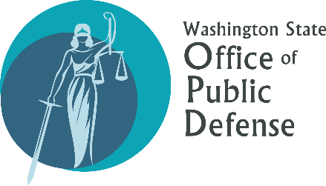Jury Selection Processes in Washington Counties
The Office of Public Defense contacted County Clerks’ offices and the Administrative Office of the Courts to enquire about their agency’s role in the selection process for potential jurors. This document contains responses from individuals with knowledge of their respective agencies’ processes. Responses have been modified to remove the original OPD enquiry and related artifacts, and official county stamps, signatures, and line numbers were removed from some copies during file conversion; but every effort was made to preserve the original documents’ informational content about jury selection procedures.
In some cases, responses contained Confidentiality Notices that prohibit direct sharing of the responses. In those cases, information is provided using direct quotations, with the respondents’ understanding that information would be publicly shared. In one case (Island County), response was in the form of a telephone call. A brief summary of that conversation was provided.
Click on a .pdf or .docx icon below to view an explanation of that county or agency’s part in the jury selection process:
Administrative Office of the Courts

Washington Counties

Adams County
Asotin County
Benton County
(summary)
Chelan County
Clallam County
(summary)
Clark County
Columbia County
(summary)
Cowlitz County
Douglas County
Ferry County
Franklin County
Garfield County
Grant County
Grays Harbor County
Island County
(call summary)
Jefferson County
King County
Kitsap County
Kittitas County
Klickitat County
Lewis County
Lincoln County
Mason County
(call summary)
Okanogan County
Pacific County
Pend Oreille County
Pierce County
San Juan County
(summary)
Skagit County
Skamania County
Snohomish County
Spokane County
Stevens County
Thurston County
Wahkiakum County
(summary)
Walla Walla County
Whatcom County
Whitman County
Yakima County
